**Public Server to Private Server Connection through SSH**

* **Connect to public server**
* **Go to root**

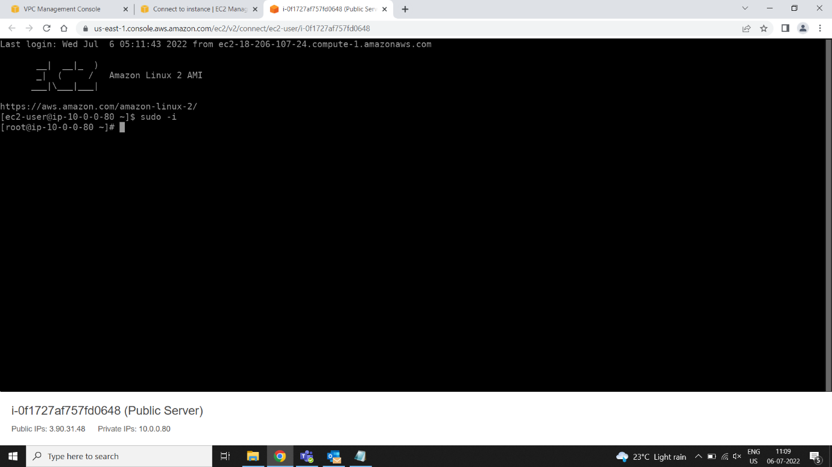

* **Create file and past the private keypair details**
* **Vi privatekeypair.pem**

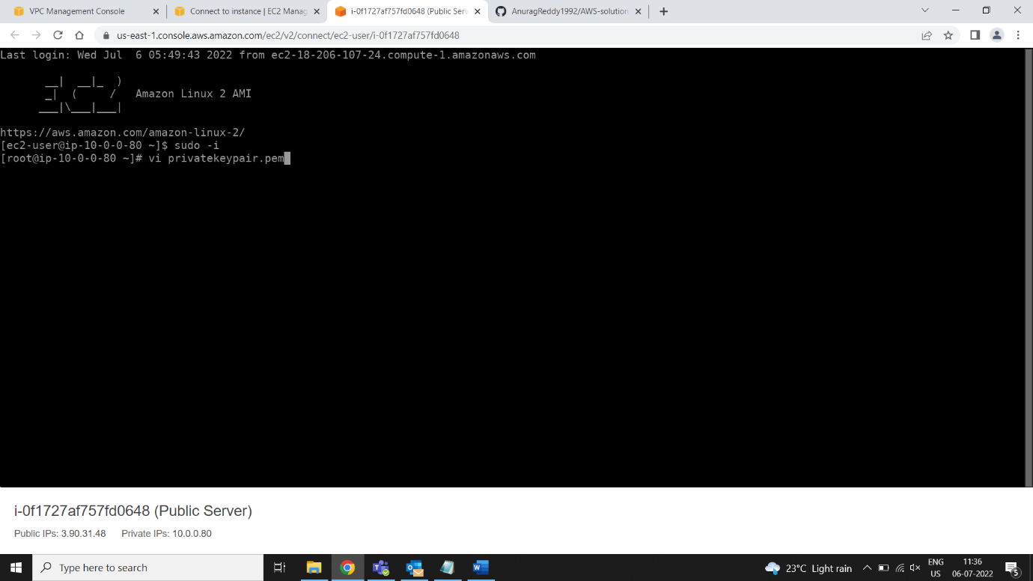

* **Open privatekeypair.pem and copy the complete data**



* **Past the complete data in Vi privatekeypair.pem and save**

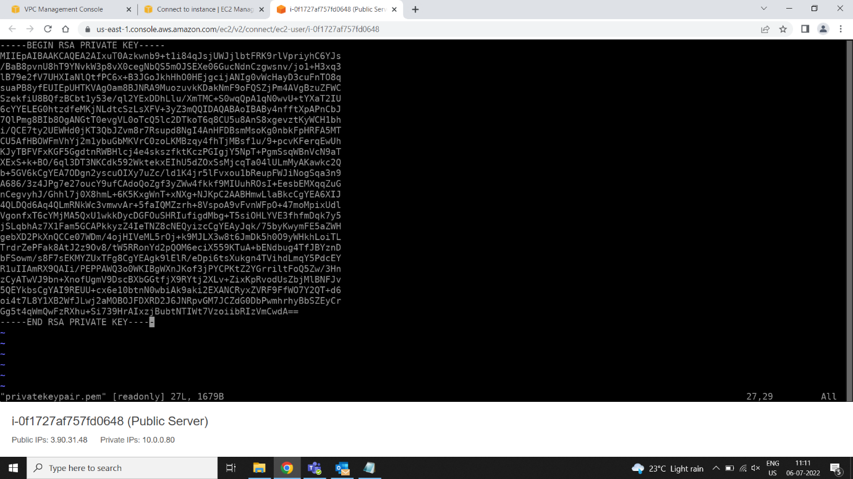

* **Change the permeation to read only to user**
* **Chmod 400 privatekeypair.pem**

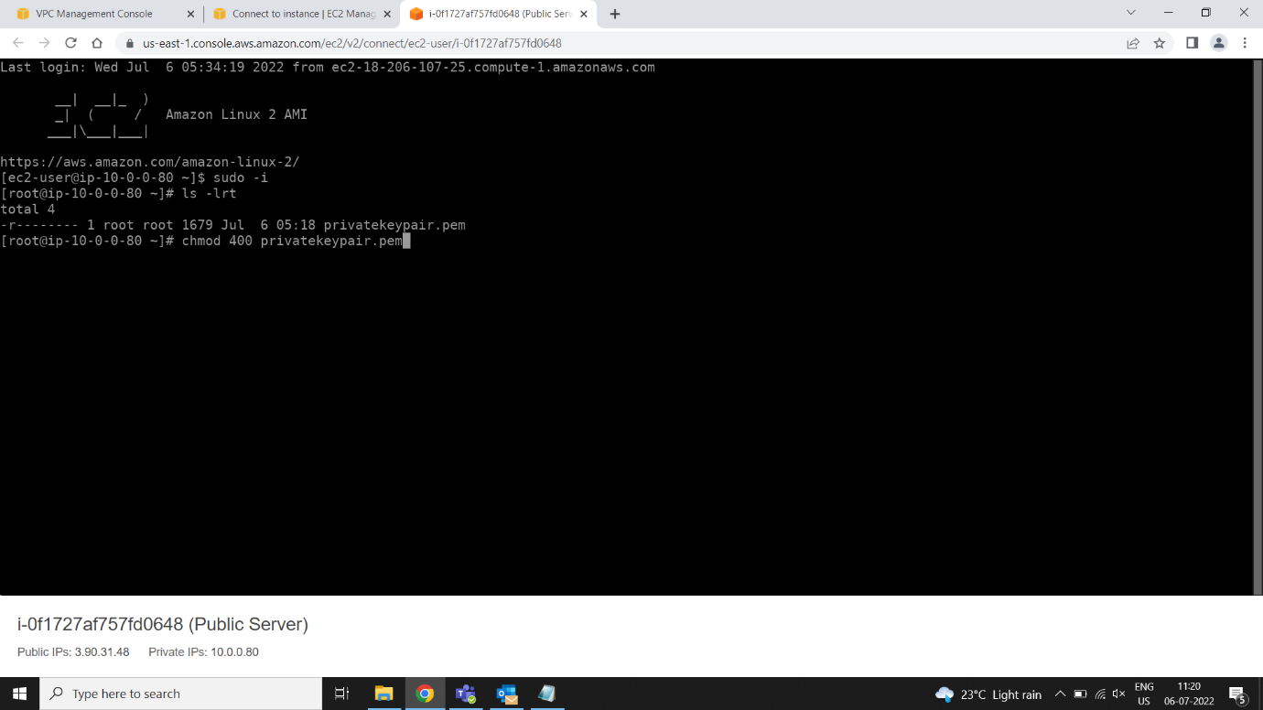

* **Ls -lrt to check the files and permissions**

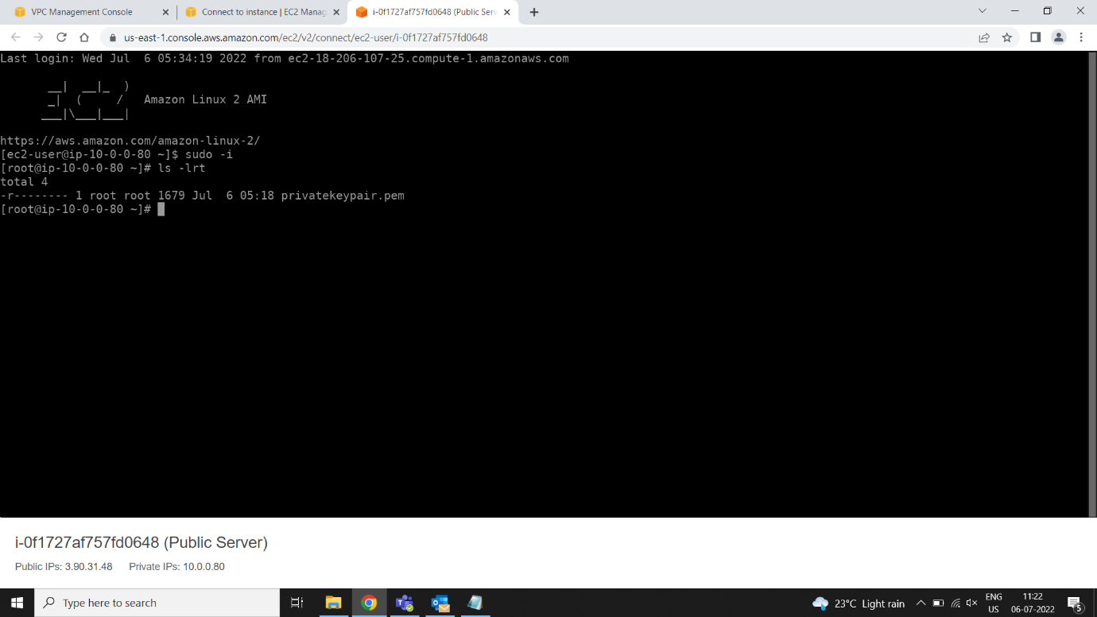

* **Copy the Private IPV4 of Private Server**

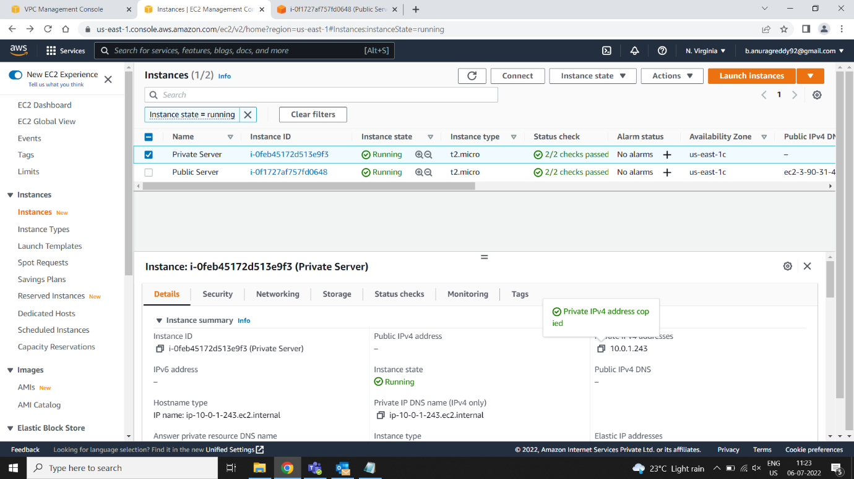

* **Connecting to private server**
* **ssh -i privatekeypair.pem ec2-user@privateIP**

